CloudCME® Access and Manage Your Transcript

Via computer
Step 1: https://spectrumhealth.cloud-cme.com/default.aspx

Step 2: Click "Sign In" on the top left, and sign in using your CWH Credentials (username and password), or your personal email address and password.

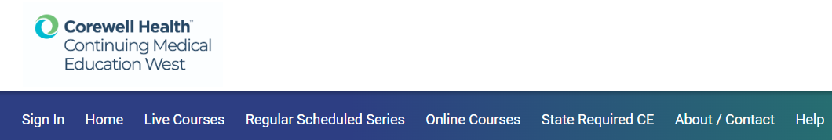
Step 3: Click the green "My CE" button on the top right-hand side of the screen. 
Step 4: Click "Transcript" from the menu.

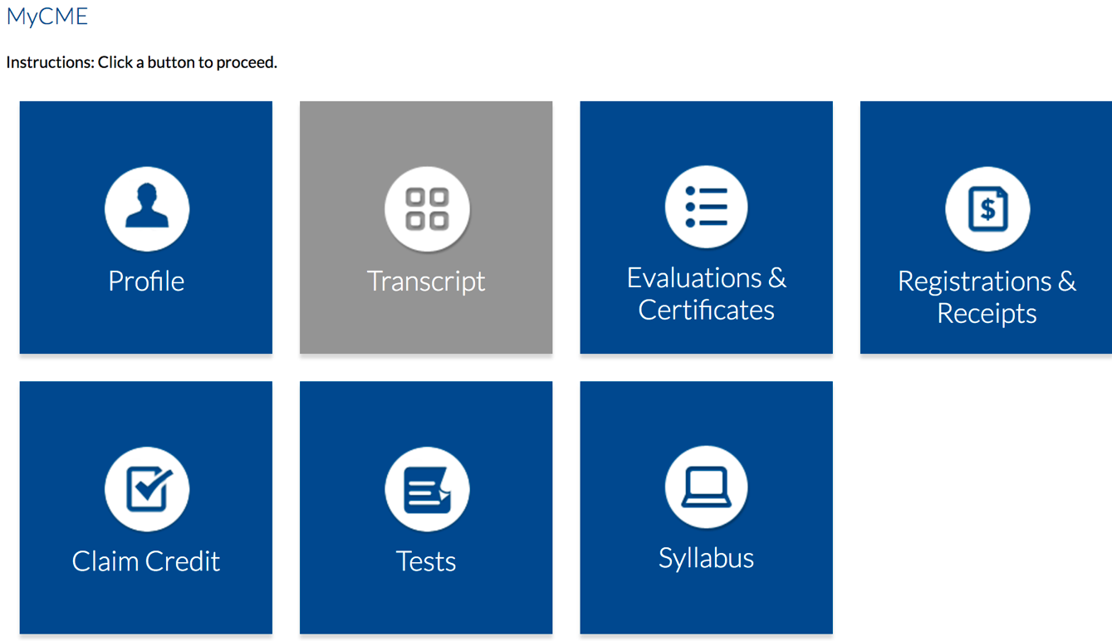

Step 5: Select a date range for the transcript records you wish to access by entering in a Start and End Date. You can email or download your transcript.

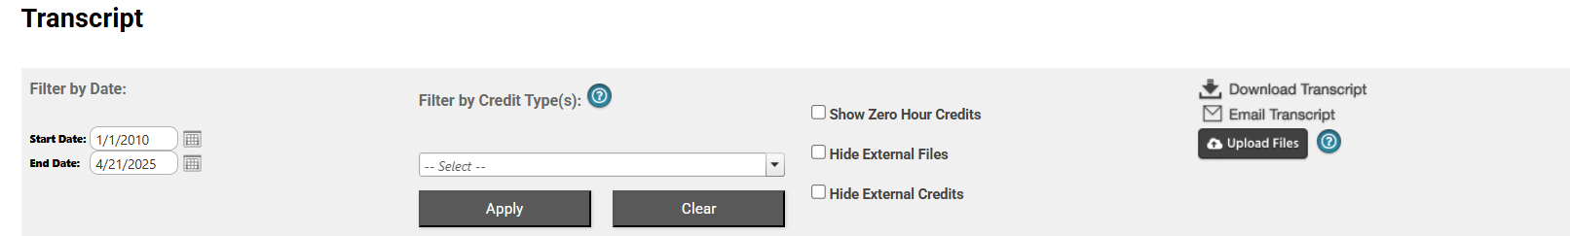
Via CloudCME App
Step 1: Open the CloudCME App.
Step 2: Login using CWH Credentials or your email address and password.
Step 3: Use the organization code “Spectrumhealth”
Step 4: Select "My Transcript" on the menu.
Step 5: Select “View,” “Email” or “Save to My Device” depending on the action you wish to take.

