SHWM-CME-NCPD

CloudCME® Create an Account

Instructions for New users to create an account in the CME/CE software system are included below.

Via computer
Step 1: Go to https://spectrumhealth.cloud-cme.com. Click “Sign In” in the upper left corner of the screen.

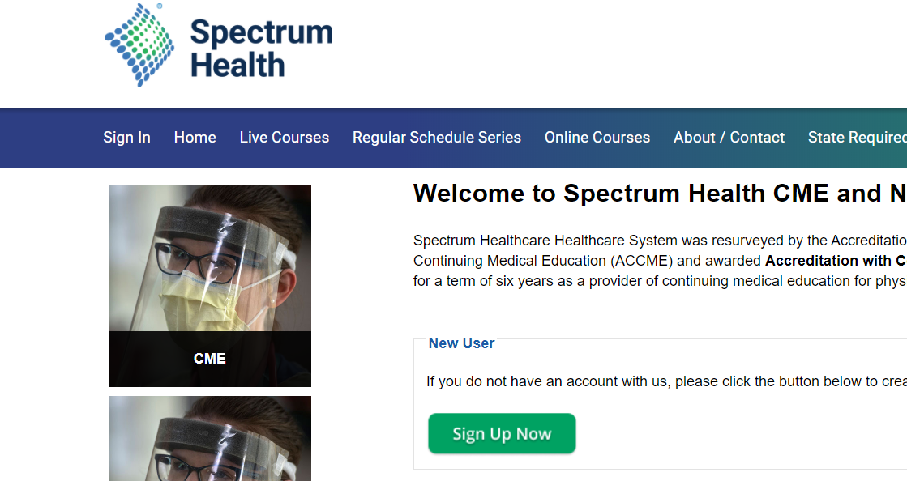

Step 2: For Spectrum Health network users, select “Sign in with your Spectrum Health User Name & Password”. Enter your Spectrum Health user name and password if prompted.

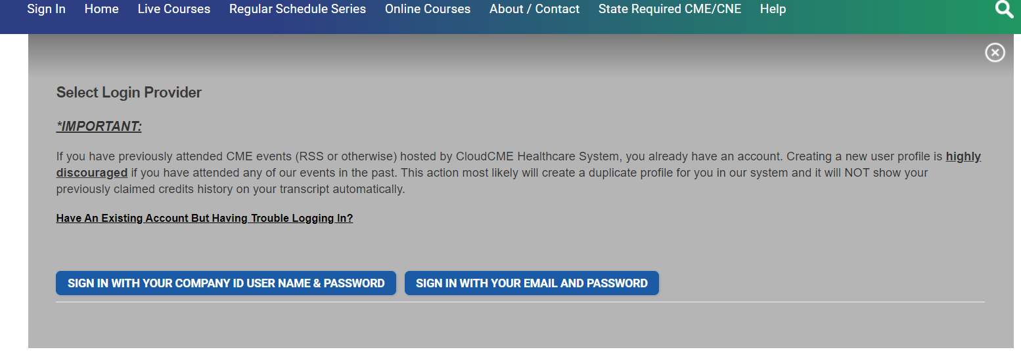

Step 3: For external users, if you don’t have an account, select “Sign in with your email and password” and then select the “Don’t have an account?” link.

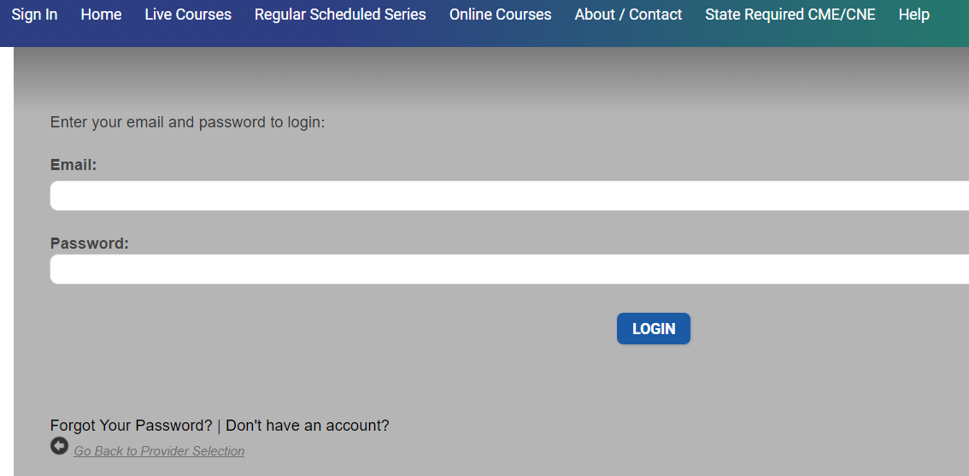

Step 4: A screen will display requiring you to enter your information. When the information has been entered, select “Create Account.” After account is created, log in by selecting “Sign In With Your Email and Password”

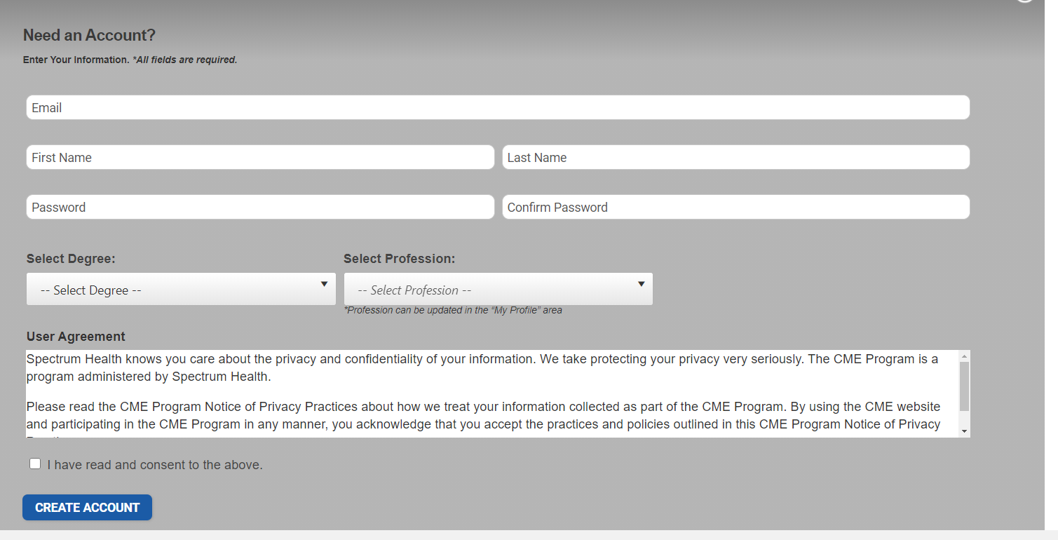

Step 5: Once Logged in, in the upper right corner click My CE and select the Profile tile. Please update additional information in your profile.
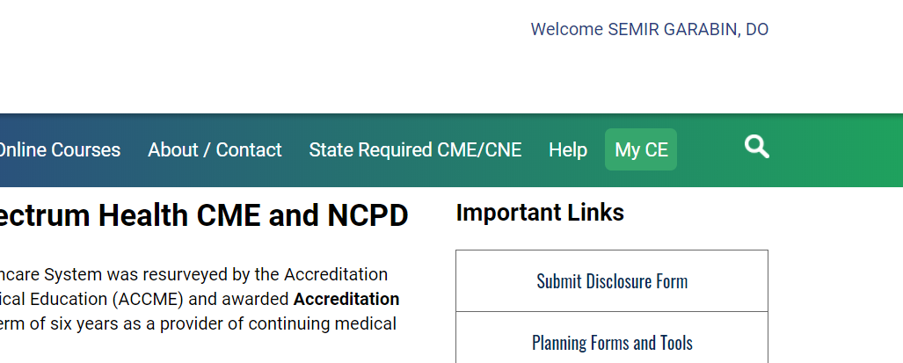

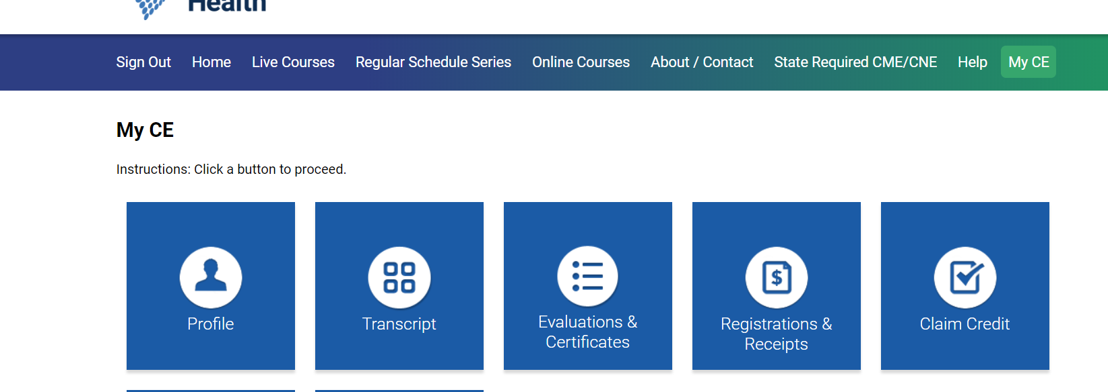

Please note: The email and password that you use when logging in from a computer will be the same that you use when logging into the CloudCME® app.

