SHWM-CME-NCPD

CloudCME® Mobile App Instructions

The CloudCME® mobile app provides quick access to most of the CloudCME® functions. You only need to download the app and login once, and then you will be able to view content, perform CE tasks, see listings of activities or check-in to activities from your device. When an event is complete, Evaluation forms and Claim Credit allow you to finalize the CE process.

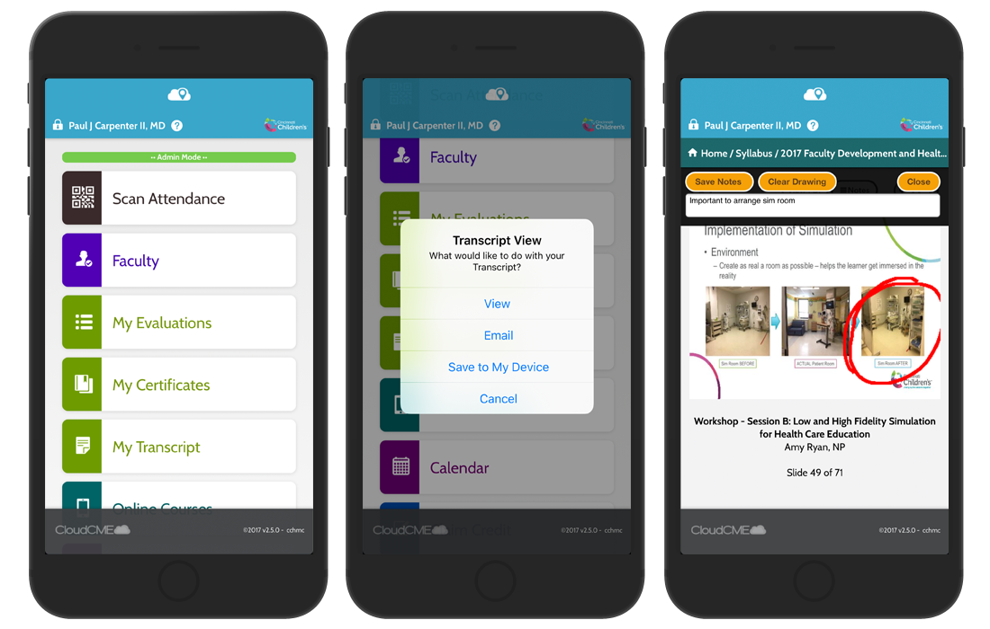
Download Links
Download the app for free from the app store and login using the organizational and security code, spectrumhealth, (which is the prefix for your CloudCME® portal url, spectrumhealth.cloud-cme.com) and then enter your CloudCME® login name and password. Both institutional Single Sign-On and non-Single Sign-On CloudCME® account types are supported.
Apple iOS - https://itunes.apple.com/us/app/cloudcme/id624053130?mt=8
Google Android - https://play.google.com/store/apps/details?id=com.multiweb.checkin

Via CloudCME® Mobile App

Step 1: Download App if you have not already
Step 2: Open the app, use organization code: spectrumhealth (Note: entering the organization code needs to be done before entering your user name and password. If the username and password screen appears first, scroll all the way down to the bottom of the screen for the “back to organization screen arrow”)
Step 3: Click the Login or Create Account button.
Step 3: Login using your email address and password.

The features that are available in the CloudCME® Mobile App are set by your institution. Your CloudCME® mobile app features may include:

My Profile – allows you to create and manage your account in CloudCME®.

My Evaluations -allows you to complete activity evaluations.

My Certificates – allows you to view, print or email certificates.

My Transcript – allows you to view, print or email your transcript.

Online Courses – allows you to access online activities and complete them.

Syllabus – allows you to view activity syllabi, view up-loaded presentations and take notes on the displayed presentations.

Calendar – allows you to view upcoming CE activities.

Scan Attendance – allows you to record your attendance, when applicable.

Audience Response - allows you to participate in audience response polls, when applicable.

Faculty – if you serve as faculty to CE activities, this allows you to access and complete your faculty assigned tasks including disclosure of financial relationships.

The mobile app menu may vary depending on your institution’s policies.

