Coordinators Training Manual for Regularly Scheduled Series (RSS)

September 2020

All rights reserved © 2017, 2020

Table of Contents
Table of Contents 2
RSS Dashboard Introduction 3
RSS Icons 4
RSS Status Definitions 6
Using the RSS Dashboard 7
SMS Texting 14

RSS Dashboard Introduction
CloudCME® offers the RSS Dashboard to assist in managing individual RSS sessions or children, as they are often referred to. Using the RSS Dashboard, you can enter the child activity title, location, objectives, specialties, assign faculty, manage faculty disclosures and upload faculty presentations. Additionally, you can generate an activity flyer.
NOTE: An Administrator must assign permission to your account via Administration > User Screen Access for you to view this screen. If you do not have access to the RSS Dashboard, please contact your Administrator.
First, log into CloudCME® by clicking Sign in with your Organization ID, enter your email, password and click the Login button.

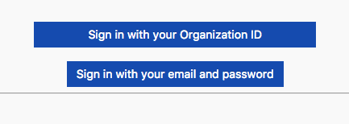

On the lower side of the screen, you will see the Administration field. Click on the Administration link located to the right of this field.

Then, from the main menu, go to Activities > RSS Dashboard. NOTE: This screen may vary depending on the access you have been given.

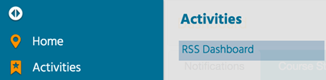

RSS Icons

The columns in the RSS Dashboard contain several icons: Status, ID, Topic, Faculty and Notes (Activity Administrators only). Below is the definition of each icon.
Status column - This column contains a status icon. As the planning process continues through the approval state, the icon displayed in this column will continue to update.

ID column – This column contains the RSS Parent ID and the RSS Children IDs.

Topic column
RSS Flyer - Click this icon, and the system will generate an activity flyer for distribution. Faculty must be assigned to the activity before a flyer can be generated. You can customize the flyer template for a unique RSS child activity or customize for an RSS parent activity, which will be applied to all child activities of the parent. See the RSS Flyer instructions below.
Calendar - Click this icon, and the calendar will display for you to view and access the scheduled RSS child activities.
Trash - Click this icon to deactivate/delete an RSS child activity. A message will display asking you to explain the reason why you are deleting the RSS child activity. Enter text and click Add Note. This note will be emailed to the Continuing Professional Development (CPD) office on file in your organization.

Faculty column

This column contains the following icons for your use. Once you have selected the faculty member from the drop-down list, click the green plus icon to add the user as a faculty member for the RSS child activity.

Once a user has been added as a faculty member, two additional icons display.

Envelope - Click this icon and a window will display for you to create an email message for faculty members. You can email both coordinators and faculty. When an email is sent, the system will record this action and place a note in the Notes section.

Red Minus - Click this icon to remove a faculty member from the RSS child activity.

Upload Presentation - An icon displays in this column when one or more faculty have disclosed a financial relationship in the disclosure form. This icon signals to upload the faculty member's presentation so that the peer review process can begin.
Notes column - The notes column is available to Activity Administrators only. The green plus sign Notes icon is in this column. Click this icon to add notes to the RSS child activity.

RSS Status Definitions
Incomplete: This status means that faculty and disclosures have not been assigned yet. RSS Coordinators/Owners will see Incomplete by default until faculty have been assigned, and disclosures have been completed. This is the initial default status of every RSS child activity.
Pending: This status represents faculty who have completed a disclosure and there was no financial relationship declared (i.e. no financial relationships were disclosed or COI was resolved).
In Review: This status represents faculty who have a completed disclosure and at least one financial relationship has been declared. The faculty member’s presentation has been uploaded, triggering a formal review for potential conflict of interest to determine if resolution is needed.
Approved: This represents faculty who have completed a disclosure, either no financial relationships were declared or, if identified, resolution of conflict of interest has been satisfactorily completed.
Rejected: This represents faculty who have completed a disclosure, a financial relationship has been declared and the conflict of interest is not able to be satisfactorily resolved. The activity is rejected. The coordinator would remove this faculty member and would need to select a new faculty member and begin the process again.
NOTE: The system will generate an email to the administration email on record when the RSS status changes to Pending if in Administration > Preferences the checkbox "Send email every time an RSS status is pending in the dashboard" is selected.

Using the RSS Dashboard
The RSS Dashboard provides a minimized view to easily manage RSS activities. You will see all activities that you have been assigned as coordinator/owner except those that are approved (unless Approved is selected in the Status search method).
There are a variety of methods to search the RSS Dashboard. You can search by day, week or month and by date range or status.
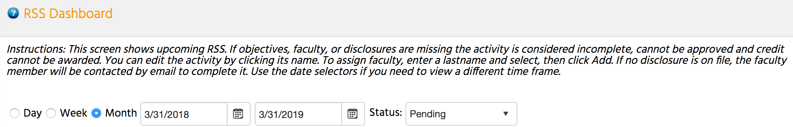
In the below screenshot, a date range has been entered, and the Status is set to Pending. You can also search by changing the status to All, In Review, Incomplete, Approved or Rejected. NOTE: Please see the section titled RSS Status Definitions provided above for a definition of each status.
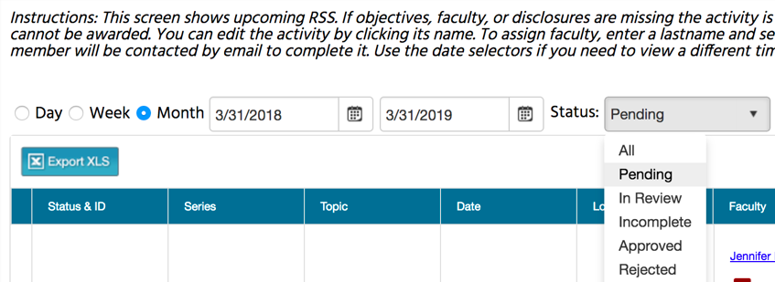
The data table contains several columns to assist you in managing the activity planning process. Columns include: Status, ID, Series, Topic, Date, Location, Department, Faculty, Disclosure, Upload Presentation, Objectives, Audience, and Owners/Coordinators.
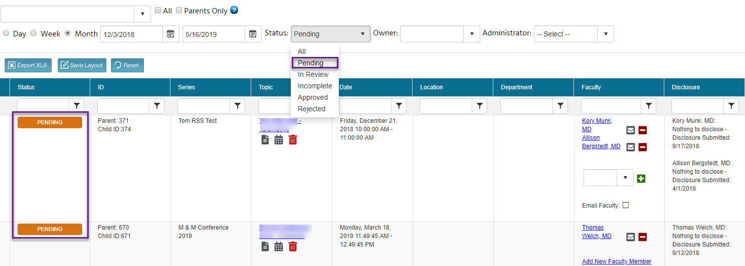

Click the calendar icon in the Topic column and go to the date of the first RSS child activity.
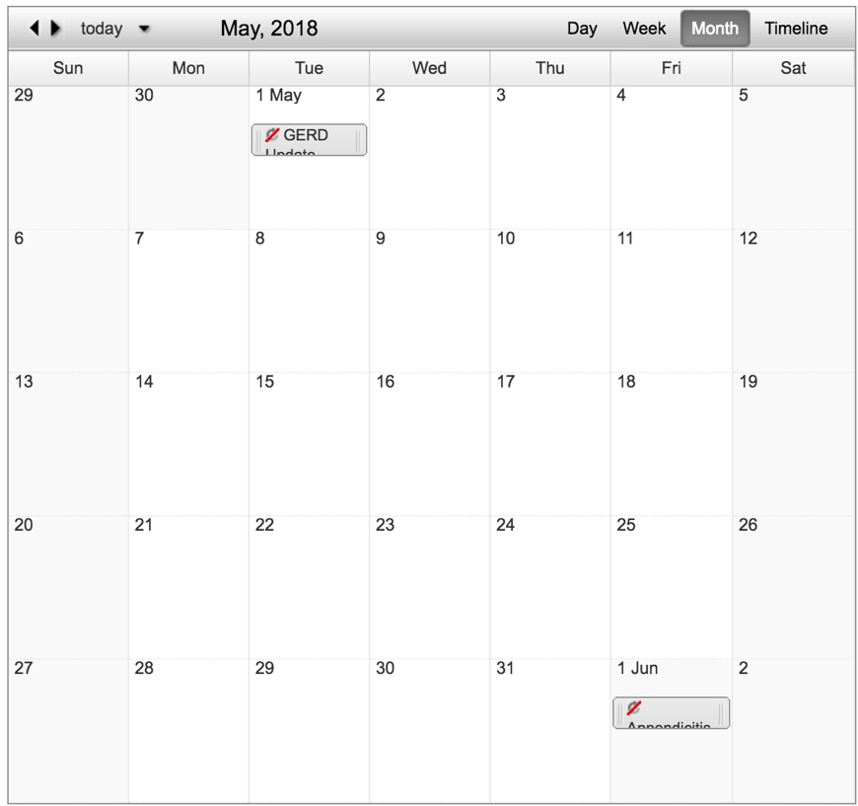
Enter each RSS child activity as you plan topics throughout the year. To edit a child activity, double-click on the child activity in the calendar. The radio button will default to Edit only this occurrence. Click OK.
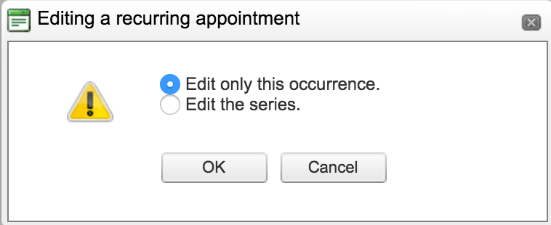
You can edit the title of the child activity. If you need to revise the day or time the activity will occur, click the Options button.
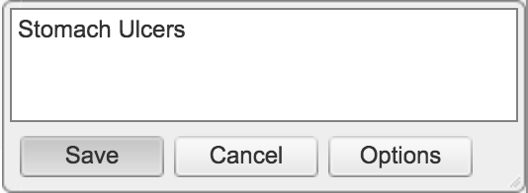
A new window will display. You can edit the date and time of the child occurrence and click Save.
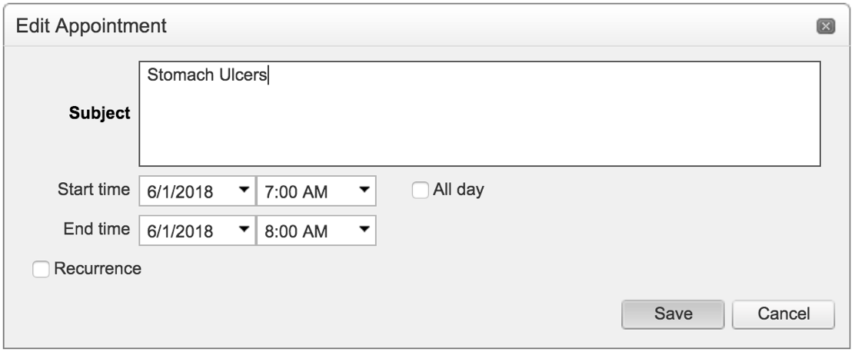
Click the child activity from the RSS Dashboard, with the updated title, and a new screen will display. Enter the RSS child activity information on this screen.

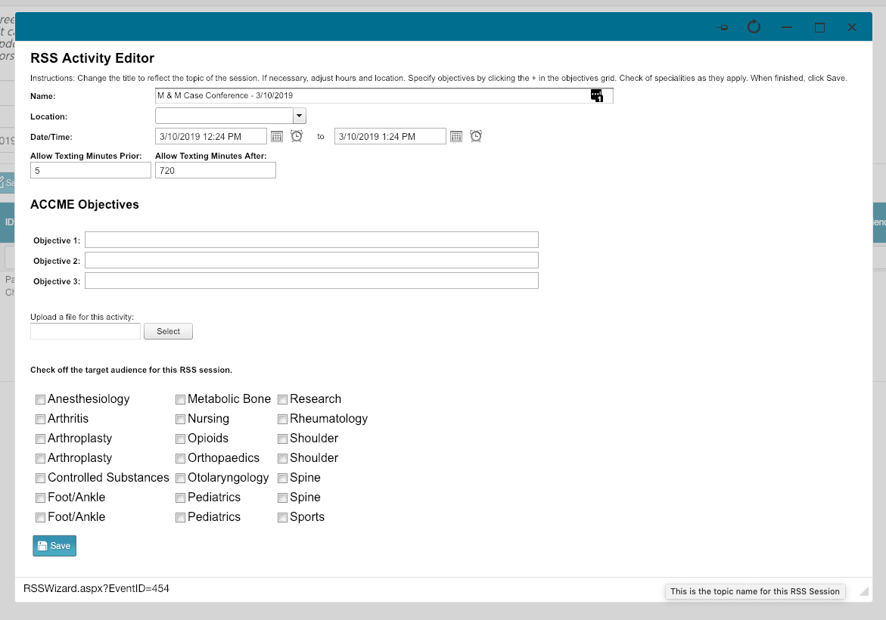

Enter the RSS child activity Name, Location, Date/Time, Allowing Texting Minutes Prior, Allow Texting Minutes After, and Objectives. Upload a file for the activity and select the specialties that are the target audience for the activity. NOTE: The child activity title will appear on users’ transcripts.

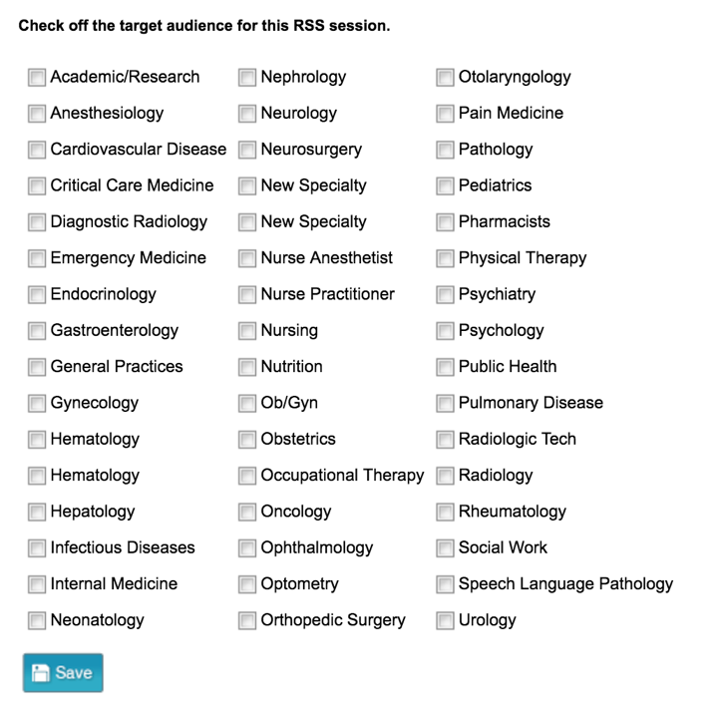

When all information has been entered, click the Save button.
To customize the RSS flyer, click the RSS Flyer icon and then click Download Microsoft Word Version. The flyer will open as a Word document. Make the desired changes and save the document to your desktop.
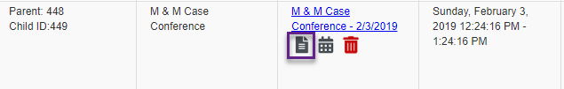
To associate the revised flyer with a unique RSS child activity, click the Upload Flyer button, select the revised flyer from your desktop, and click the Submit button.
If you want to associate the revised flyer to the RSS parent for use per each child activity of the parent, click the Upload Flyer button, select the revised flyer from your desktop, and check the checkbox Use flyer/templates for Parent?. Then, click the Submit button.
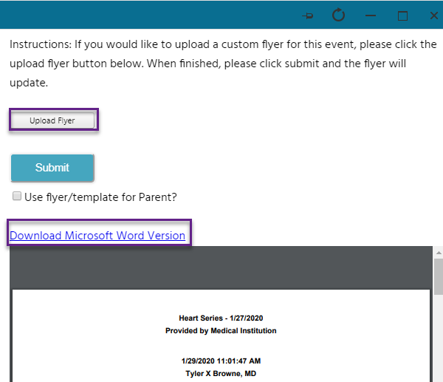

Add faculty to the child activity in the Faculty column. Type in the letters of the faculty member's last name and select from the drop-down list. Then, click the green + button. NOTE: If the faculty member does not have an account in CloudCME®, you will need to contact your administrator to either gain access to Membership Manager or have the faculty member added into the system.
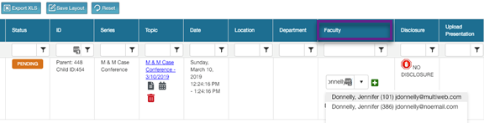
The faculty member will be added to the RSS child activity. NOTE: The status in the Status column may change from PENDING to IN REVIEW. The status can change to IN REVIEW because the faculty member declared a financial relationship on their disclosure.
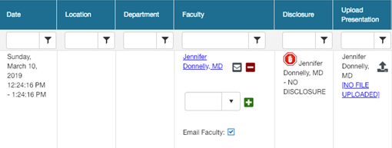
If the faculty member declares no financial relationships on their disclosure form, the status will update to Pending, and the RSS child activity is ready to be marked as Approved by the Activity Administrator. The status will update to COMPLETE.

If the faculty member declared a financial relationship(s), this will be noted in the Disclosure column, and the status will update to IN REVIEW.
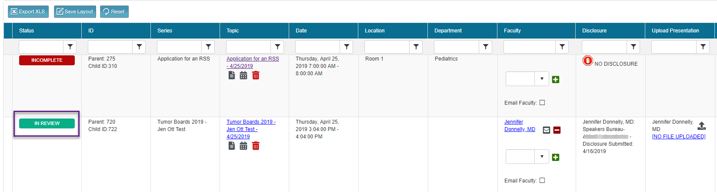
If faculty have one or more disclosed financial relationships, you will be instructed to obtain and upload the presentation (PPTX, PPT or PDF), which then triggers a peer review form in the Attendee Portal. The status will update to IN REVIEW on the dashboard. NOTE: Click the upload icon in the Upload Presentation column to upload the faculty member’s presentation for peer review.
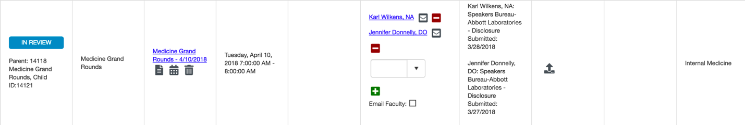
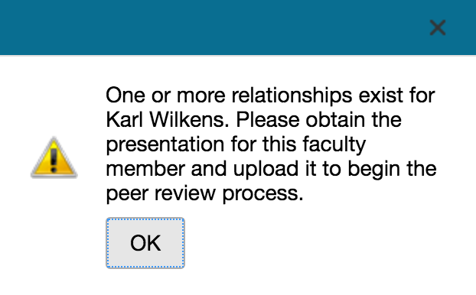
Once the faculty member's presentation has been uploaded, users who have a role of Peer Reviewer will receive an email with a link to the COI Resolution form. The presentation title, faculty name, a link to the uploaded presentation, stated disclosures and resolution questions are included in the form. Based on the question responses, this will change the status to REJECTED or PENDING. NOTE: Only one peer reviewer needs to complete the review and COI Resolution form. If additional peer reviewers try to complete the COI Resolution form, they will receive a notification that the review has been completed and no further action is needed.

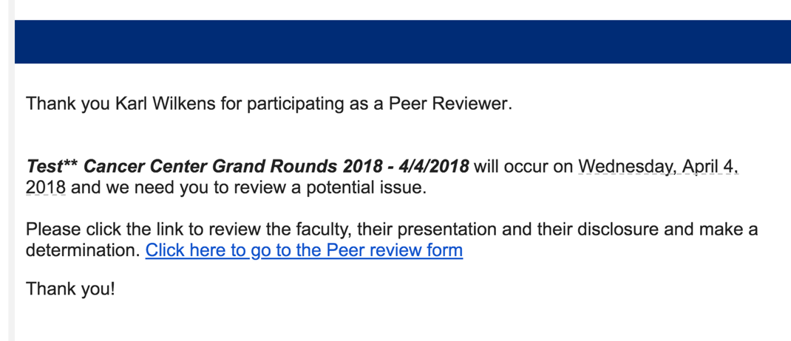

SMS Texting

These instructions assume that you have an active account in CloudCME®. If you do not, please set up your account first. You can only record your attendance {X minutes prior to the meeting, during the activity, or X minutes after the meeting}.
Step 1: First, you must pair your mobile phone to your account in CloudCME®. Text your email address, entered in your Profile, to {Enter your organization’s local exchange number}. You will receive a message that looks like the one below, that your phone number has been updated. This is a one-time operation.

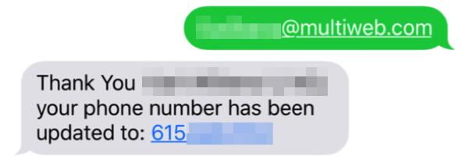
Step 2: To record your attendance to an activity, text the activity id or code that has been provided for your activity. You will receive a message back that verifies your activity attendance has been recorded.

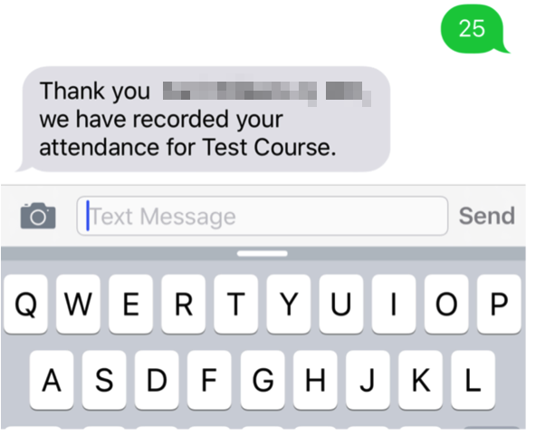

NOTE: You can only record attendance once to an activity. If you try to record your attendance an additional time, you will receive the following message.

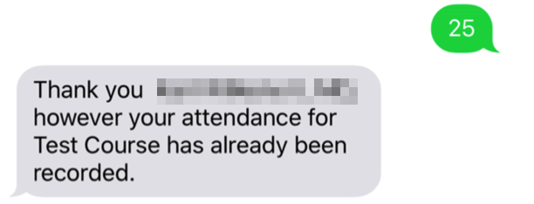

If a user attempts to use an activity code that doesn’t exist, they will receive the following message.

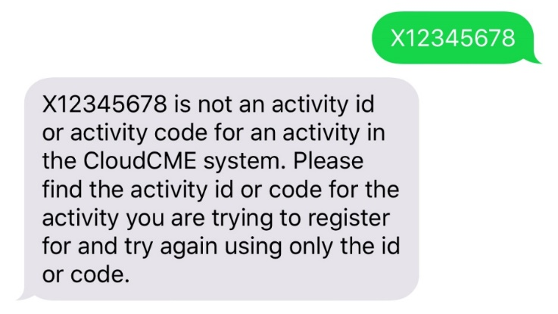

You must text an SMS text message not an iMessage, if using iOS.

